# Mean and Median of Weekly Sales

This document includes the question, the solution, and a breakdown of the code provided in the screenshot.

## Uploaded Screenshot

Below is the screenshot of the task:

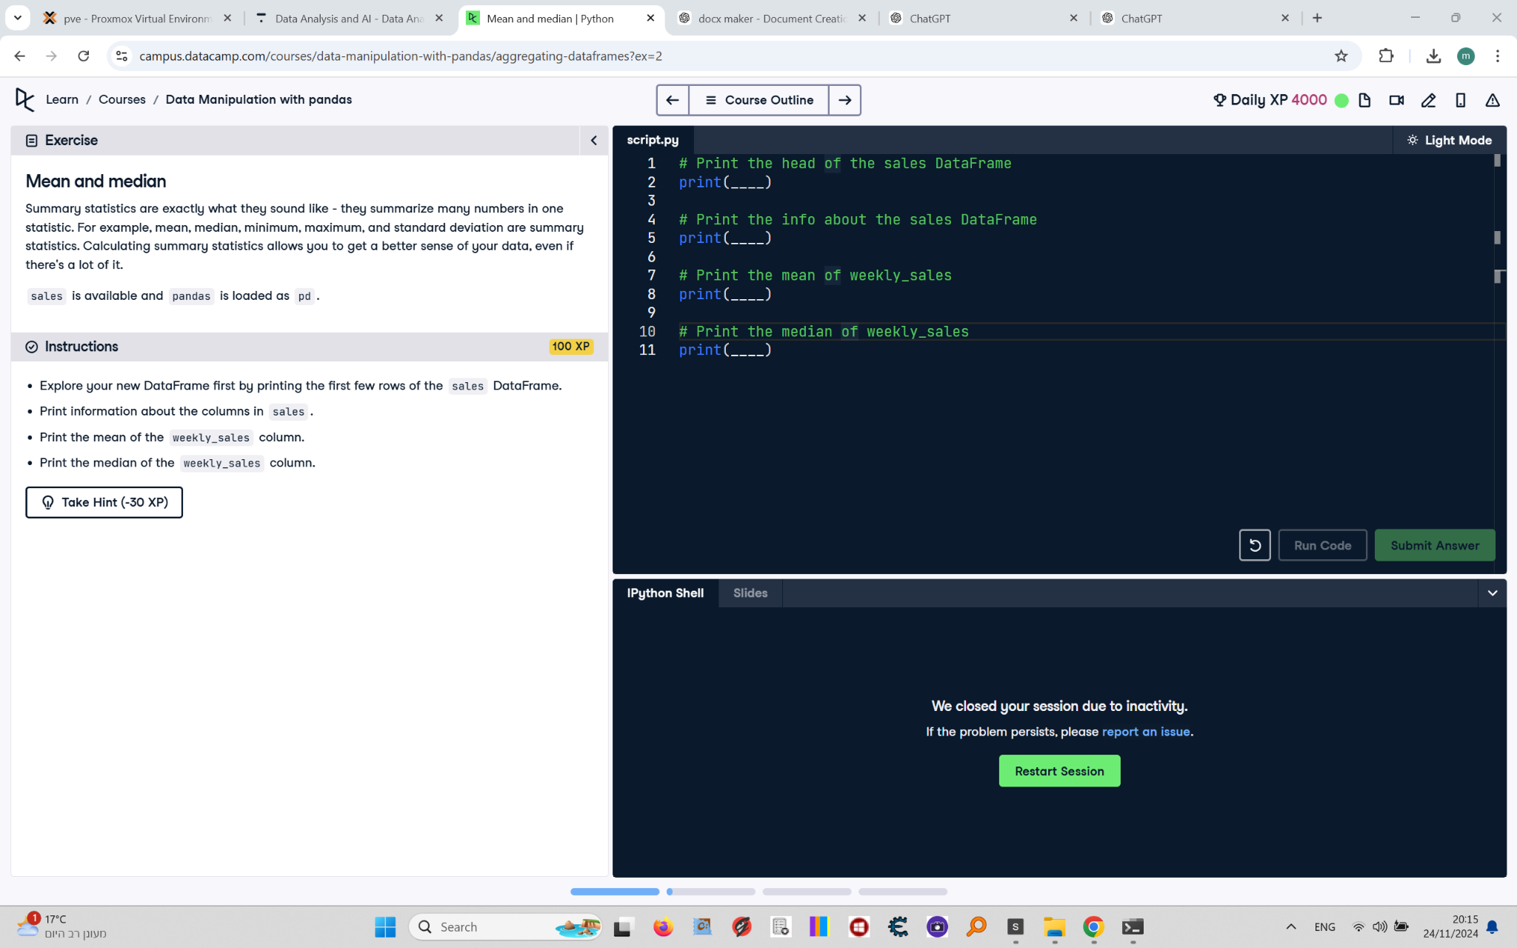

## Question

1. Explore your new DataFrame by printing the first few rows of the `sales` DataFrame.  
2. Print information about the columns in `sales`.  
3. Print the mean of the `weekly_sales` column.  
4. Print the median of the `weekly_sales` column.

## Answer

# Print the head of the sales DataFrame  
print(sales.head())  
  
# Print the info about the sales DataFrame  
print(sales.info())  
  
# Print the mean of weekly_sales  
print(sales['weekly_sales'].mean())  
  
# Print the median of weekly_sales  
print(sales['weekly_sales'].median())

## Code Explanation

# Explanation of the code:

1. `sales.head()`: Displays the first five rows of the `sales` DataFrame to give an overview of its structure and content.

2. `sales.info()`: Provides detailed information about the `sales` DataFrame, including column names, data types, and non-null values.

3. `sales['weekly_sales'].mean()`: Calculates the mean (average) of the values in the `weekly_sales` column.

4. `sales['weekly_sales'].median()`: Calculates the median (middle value) of the values in the `weekly_sales` column.